507. Perfect Number

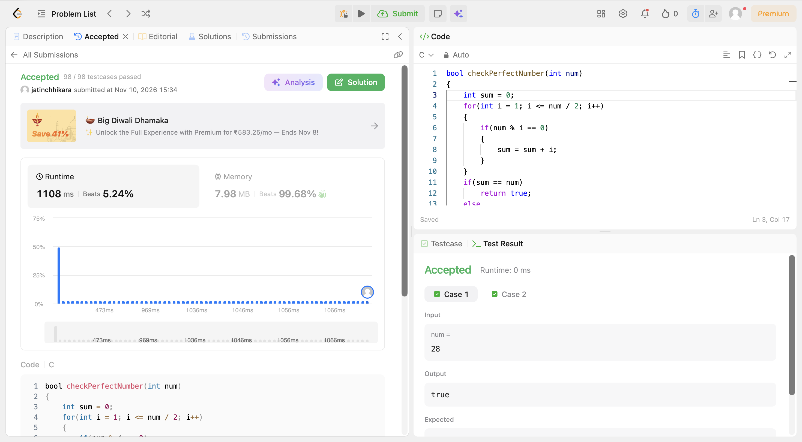
Code:
bool checkPerfectNumber(int num)
{
int sum = 0;
for(int i = 1; i <= num / 2; i++)
{
if(num % i == 0)
{
sum = sum + i;
}
}
if(sum == num)
return true;
else
return false;
}

